Algorithm for file updates in Python

Project description
A health care company has tasked me to create an algorithm using Python. This algorithm needs to check an allowed IP addresses list of permitted employees and remove ones that have been added to the remove list. These removed IP addresses will not be able to sign into the restricted subnetwork.

Open the file that contains the allow list
To start this algorithm I open the file that contains the current allow list.
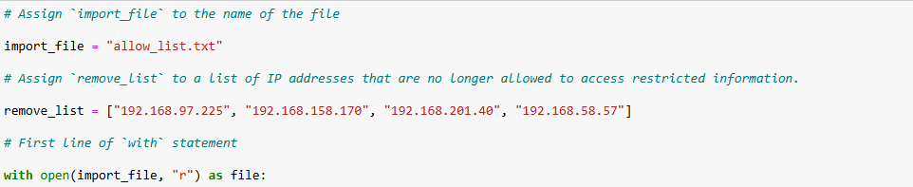
As seen in the screenshot above, I assigned the file name and the list of removed IP addresses. Then I used a with statement alongside the open() method in order to open the file in read-only mode since I specified the “r” argument.

Read the file contents
Next, I read the file and displayed the files contents to check what it contained.
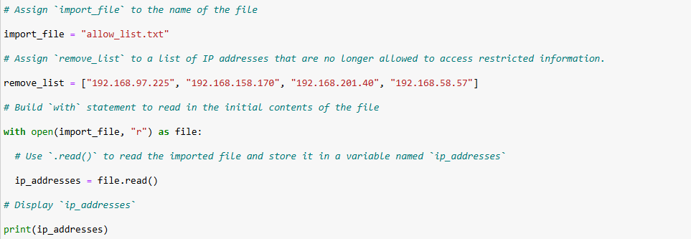
Using the read() method within the with statement allows access to the contents of the file so that I can start manipulating the allowed IP addresses.

Convert the string into a list
The contents of the file now needs to be converted into a list so that each element can be analyzed and changed accordingly.
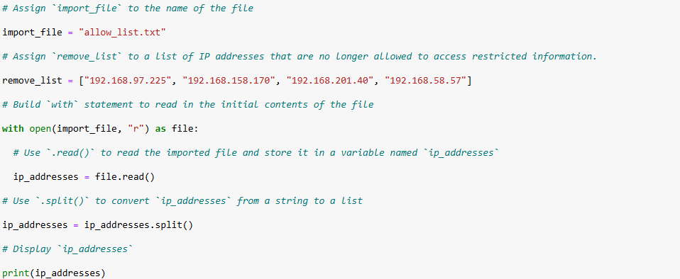
In the above screenshot, I used the split() method to convert and reassign the ip_addresses variable to a list of IP addresses instead of one string full of them.

Iterate through the remove list
In order to check though and analyze the contents of the allowed IP addresses list, a for loop must be used to iterate through each element.
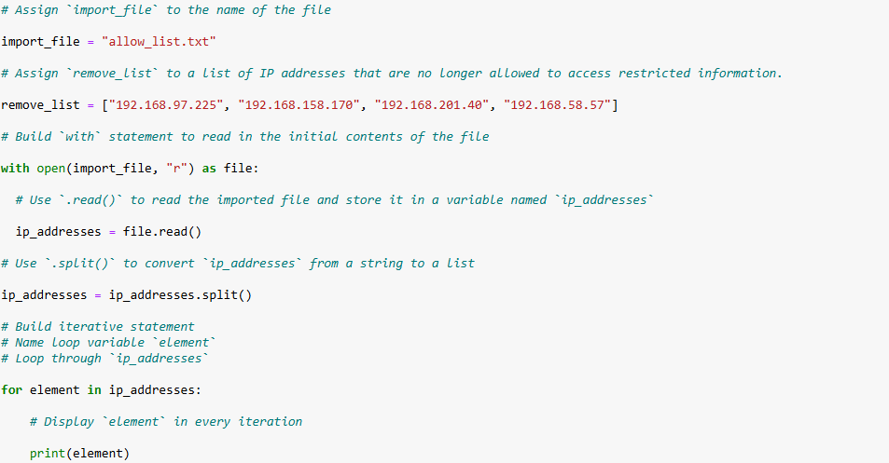
I named the loop variable element and I iterated through the elements of the ip_addresses list.

Remove IP addresses that are on the remove list
The list being iterated through now needs to be analyzed for if there are any matches with the removed IP addresses list. When there is a match, the IP address should be removed from the approved IP addresses list.
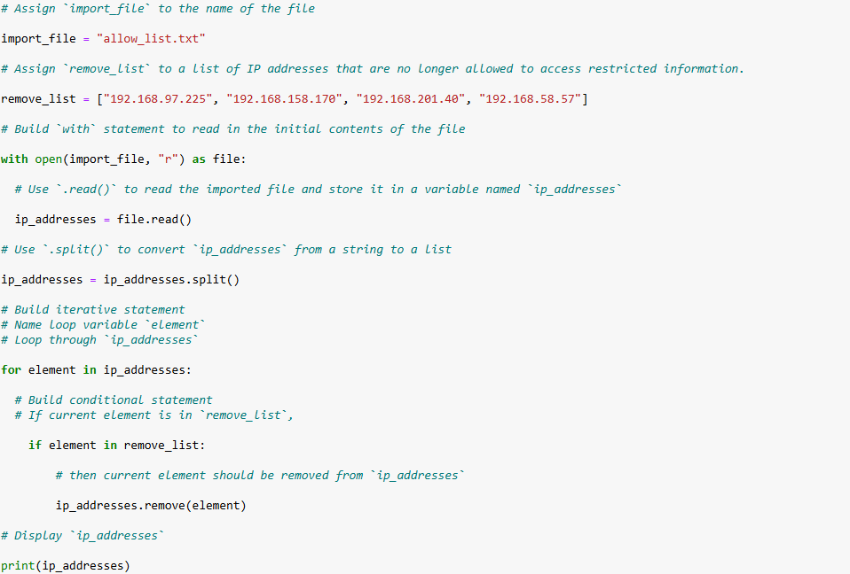
Within the for loop I use a conditional statement to check if the element is in the remove_list. If the element is in remove_list, the remove() method will remove the specified element from the ip_addresses list.

Update the file with the revised list of IP addresses
Finally the allowed IP addresses file needs to be reopened to rewrite the new list to it.
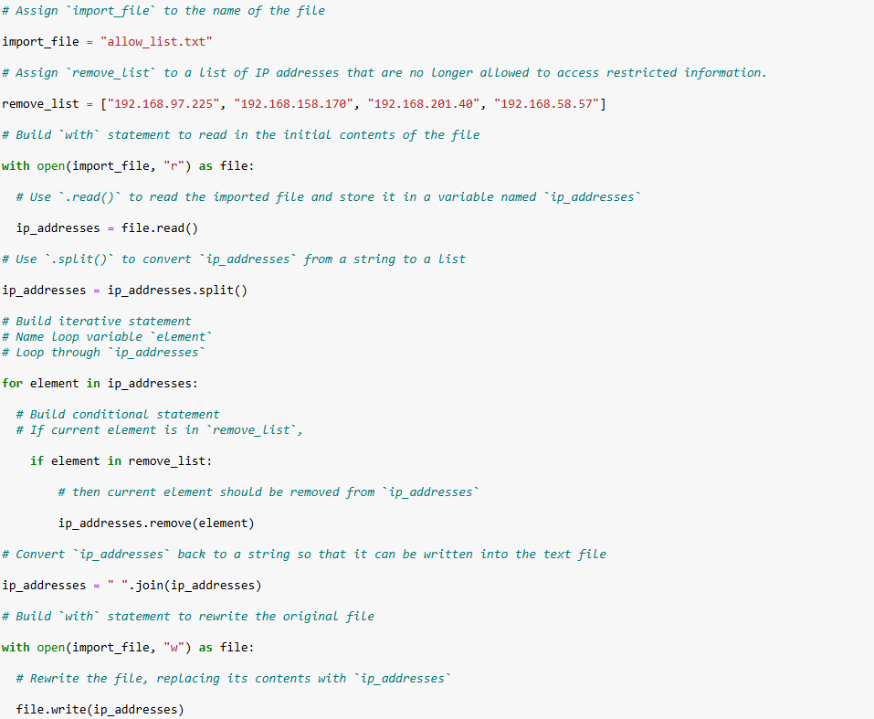Before the file is reopened I used the join() method to convert the list back to a string by combining the elements and separating them with spaces. This is done so that allowed IP addresses are back in a format that can be put into the text file. Similar to the beginning of the algorithm, a with statement alongside the open() method is used to open the file but this time in write-only mode. The write() method is then used within the with statement to replace the text in the allow_list.txt file with the new string of IP addresses.

Summary
To complete the goal I was tasked with I used Python to read a given file and analyze it. The open() method is used to open up the file and read and write to it. The split() method is used to convert a string of IP addresses to a list for easy modifications. Since the IP addresses are converted to a list, the elements are easily iterated though and checked for matches with the removed_list. If a match is found the element will be removed from the ip_addresses list. Once the iteration through the list is complete the list will be converted back to a string using the join() method and then using the write() method, the new string of IP addresses replaces the contents of the allowed_list.txt file.

